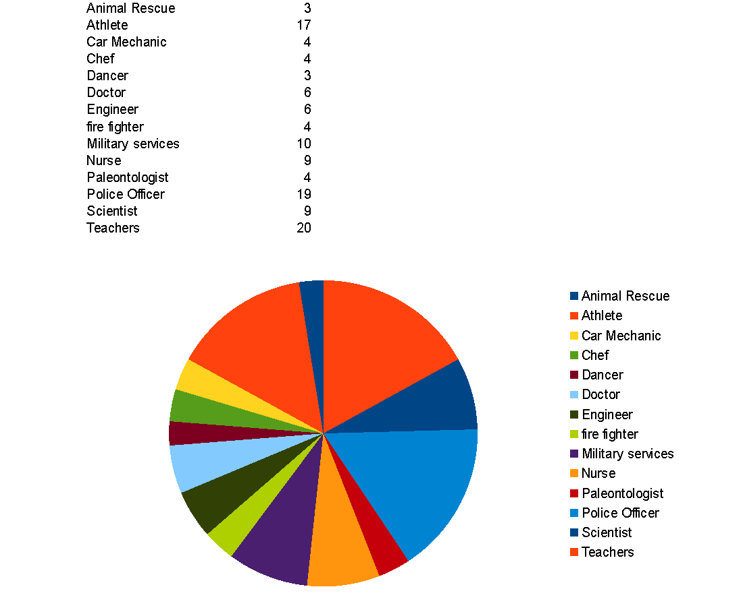

Counselor's Corner:
Happy New Years! I hope you all had a wonderful holiday season. I hope that 2018 brings new joys and accomplishments to all. Usually as the new year begins many individuals look at what goals they would like to set for the year. It is a great time to reflect on what you have accomplished and what projects you would like to begin. Family meetings are a great way to look at what is working well and what could be improved (such as chore assignments and management, family time together without any technology -cell phones, video games, tablets, etc.). As a family, look at ways you can work together, learn together and play together. Communication and cooperation are two skills that we use a lot in our lives. The earlier we can teach these skills in our families the more are family members can engage well with us and with others.
Sharon Rivas, LCSW
Groveland School Counselor

